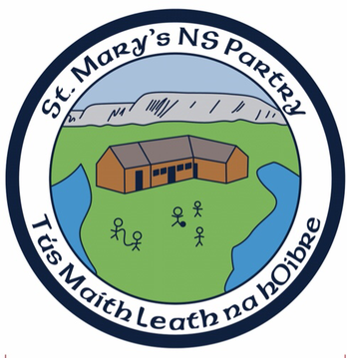

St. Mary’s National School
ANNUAL ADMISSION NOTICE in respect of admissions to the 2024/2025 school year

Admission Policy and Application Form
A copy of the school’s Admission Policy and the Application Form for Admission for the 2024/2025 is available as follows: –
On request: By emailing stmarysns2017@gmail.com or writing to: St. Mary’s NS, Partry, Claremorris, Co. Mayo.
Website: It is available to download on the school website under the New Infants tab. https://www.stmarysnspartry.com/

PART 1 - Admissions to the 2024/2025 school year

Application and Decision Dates for admission to 2024/2025
The following are the dates applicable for admission to Junior Infants/First Year

The school will commence accepting applications for admission on | January 1st 2024
The school shall cease accepting applications for admission on | February 1st  2024
The date by which applicants will be notified of the decision on their application is | February 22nd 2024
The period within which applicants must confirm acceptance of an offer of admission is | February 22nd - March 10th 2024

*Failure to accept an offer within the prescribed period above may result in the offer being withdrawn
Note: the school will consider and issue decisions on late applications in accordance with the school’s admission policy

Number of places being made available in

The number of places being made available in junior infants | 14
The number of residential places is (boarding schools only) | N/A
The number of non-residential places is (boarding schools only) | N/A
The number of places being made available in the special class* catering for children with [insert category or categories of SEN catered for in the special class] is | N/A

