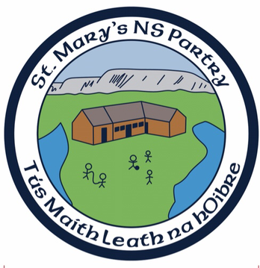

Healthy Eating Policy St.Mary's N.S.

Introduction
In St. Mary's National School we recognise the importance of healthy eating and the benefits which the children gain from being 'informed' regarding healthy eating habits.
Healthy eating in childhood:
Can help improve performance in class and at play
Can help improve concentration
Meets children's nutritional needs for growth and development
Encourages good eating habits for life
The children are made aware of the advantages of healthy eating in the course of their 'Health Education' programme.

Rationale
The Healthy Eating Policy is an essential part of the school plan because:
- It improves the nutrition standard and eating habits of all in school
- It helps to clarify the schools position on foods encouraged/discouraged
- It acts as a guideline for any new staff or families joining the school
- It ensures that the message children receive from both teachers and parents is consistent
- It ensures that what is taught in the classroom is put into practice outside the classroom
Policy Content

Promoting Healthy Eating in St.Mary's National School

Healthy eating within the S.P.H.E. Curriculum
l. The S.P.H.E. Food and Nutrition Curriculum implemented by the teachers in St. Mary's National School outlines key issues relating to food and nutrition and these are explored to the depths appropriate for each class,
2. In the delivery of S.P.H.E. an overview of healthy eating includes reference to the following points:
- Food and nutrition are important for growth and development
- Variety, balance and moderation: The Food Groups and different nutrients
- Food Hygiene
- Food choices and factors influencing these

Promoting healthy eating messages
The following points are considered in the implementation of our healthy eating programme
- Good nutrition is essential for school children. They need to receive a sound understanding about why a variety of food is important for their optimum growth, development and health.
- They should be encouraged to have practical experience in preparing their own lunches and meals.
- A positive attitude to food should be encouraged. Children should enjoy their food. It is important to communicate the message that all foods have a place in a balanced diet. Foods should not be labelled as 'good' or bad'. Food should never be used as a reward.
- Children may need three meals and three snacks each day to ensure that their appetite and energy needs are met. The size of meals and the number of snacks required will depend on the child's age and stage of development.
- Physical activity is integral to any healthy eating programme, and hence is also promoted and encouraged.

Communicating the 'Healthy Eating Message'
The Food Pyramid is the primary education tool used in St.Mary's National School to communicate the healthy eating message. The Food Pyramid is used as the basis for healthy eating training. It is the fun way to teach children about the different food groups and the nutrients in each group. Children's knowledge regarding the food pyramid is refreshed each year so as to ensure continuity in the healthy eating programme.

The Healthy Lunchbox
The children are encouraged to bring a healthy lunch to school each day. Chewing gum and fizzy drinks are banned, Friday's are treat days when children can bring a small treat to have after their lunch.

The 'Eating' Environment
- Children eat their lunches in their classrooms.
- They are encouraged to sit while eating.
- They are encouraged to wash their hands before and after eating.
- They are not rushed while eating.

