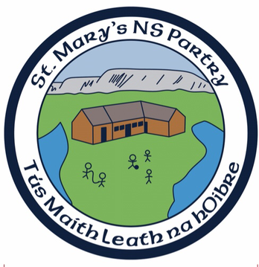

St. Mary’s National School

Equality & Gender Equity Policy

St. Marys’ N.S. seeks to promote the principles of justice and equality for all members of the school community. In this regard:

- The enrolment criteria will not differentiate between pupils from different social strata. There is an equal right of access under the school’s Enrolment Policy.

- It is school policy to provide a gender balanced range of resources in curricular areas - textbooks, ancillary materials, software, sports equipment etc.

- Every opportunity will be taken to promote gender equality through the discreet and hidden curriculum

- Teachers will ensure that the language used in the school to mediate the curriculum is gender balanced and will avail of opportunities to raise pupils’ awareness of unconsciously held attitudes

- There will be no differentiation between the sexes in the allocation of classes to teachers

- As agreed with the Board of Management and parents all pupils in St. Mary’s N.S. will wear a school uniform

- Nothing may appear in an advertisement which would indicate a preference for one gender over another

- No question will be asked at interview which could be interpreted as discrimination on gender grounds

- This school is an Equal Opportunities Employer.

