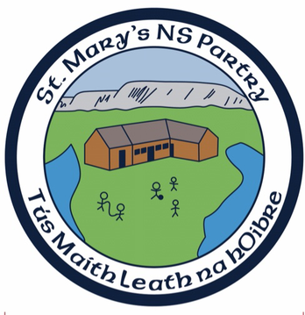
St. Mary’s National School

Emergency Closures Policy

Introduction:
The school policy on emergency closures was drafted as a whole school exercise, involving parents, pupils, staff and Board of Management.

Rationale:
The need for the school to produce a policy on emergency closures in recent years is primarily due to:

- Inclement weather, such as heavy snowfalls, high winds etc.
- Any interruptions to water supply or electricity supplies

Relationship to School Ethos:
St. Mary’s N.S. strives to provide a child friendly, secure environment catering for all the needs of all students as far as is practicable and where respect is fostered in a culture which values diversity and difference.

Aims and Objectives:
- To provide for the welfare of all pupils while on the school premises
- To ensure a safe, child friendly school environment is available to all children
- To comply with Health and Safety legislation

Procedures

Heavy Snowfall:
In the event of a heavy snowfall, the Principal shall consult with the Chairperson of the BoM as soon as is feasible, and a decision will be made as to whether it is in the interests of all parties to close the school.

If it is decided to close the school, the school authorities will contact the local radio station, ‘Midwest’ and request that regular announcements be carried on the airwaves that the school will not be opening, parents will be contacted individually via text.

All bus operators, servicing the school and the Morning and Afterschool Club will be contacted by the Principal or another designated person, confirming that the school will not be opening. If the snowfall is prolonged over a number of days and the school is closed indefinitely, parents and bus operators will be informed of re-opening dates through the local radio station and Aladdin/text.

Disconnection of Services:
Where water or electricity services to the school are to be disconnected, a week’s notification is normally given to the school authorities. This enables the school to furnish the parent body with the relevant advance warning of such closures via circular or text. It is not the policy of the school to confirm such closures through the local Radio station.

High Winds/Thunderstorms:
The procedures in place for heavy snowfall are generally replicated in the event of storms/lightning i.e. parents and bus operators are contacted via local radio or Aladdin and informed that the school will remain closed. If the school has already opened and is in operation when high winds etc. occur and remaining on the premises is a risk to all - teachers will remain on the premises until all the children have been collected by either parents/guardians or bus operators.

Critical Incident/Death:
In some instances, the school might remain closed for pupils in the event of a critical incident or death of a staff member or pupil. Parents are informed of such closures either by email or text. In this particular instance, the school may remain open to staff and BoM if issues such as church services, Guards of honour, readings or counseling is required (See Critical Incident Policy).

Please note:
All half days and in-Service closures are notified to parents at least one week in advance.

Roles and Responsibilities:
Emergency closures in the school place particular responsibilities on various personnel within the school chain of command;

- Positive school community feedback
- Compliance with Health and Safety legislation
- Maintaining a safe school environment for all staff, children and parents

Implementation and Review:
This policy will be implemented immediately.

This policy will be reviewed in light of an unplanned event, that lead to unscheduled school closures but not later than 2025.

